**Full Stack Experiment 10**

**Name:** Abhay Mathur **SAPID:** 60017210016 **Batch:** A1

Theory:

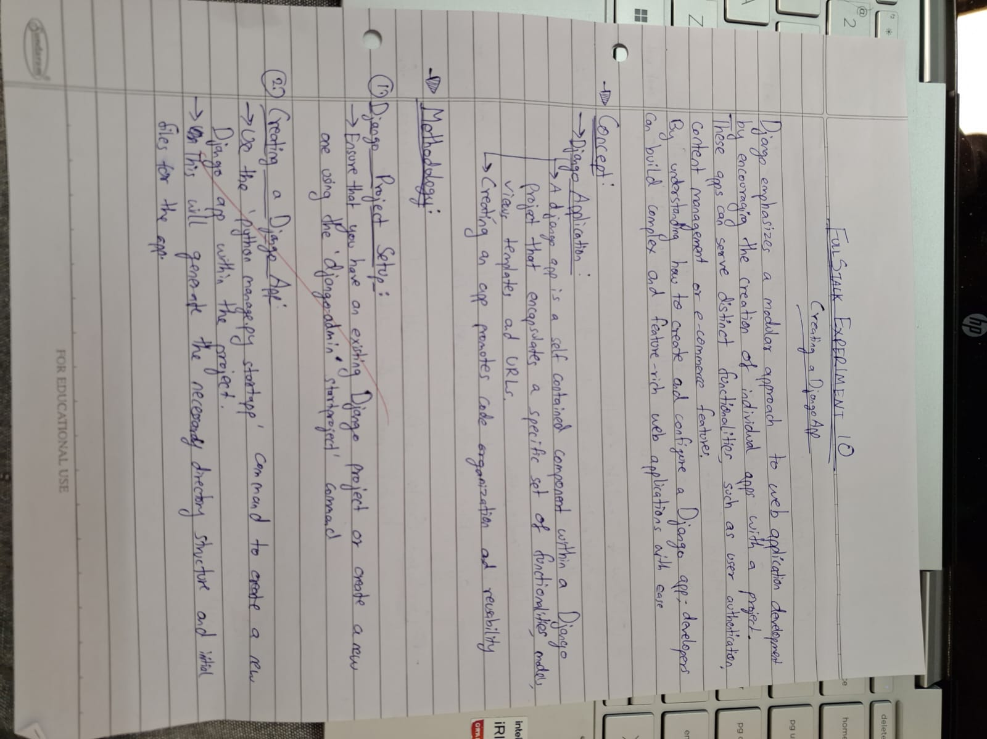

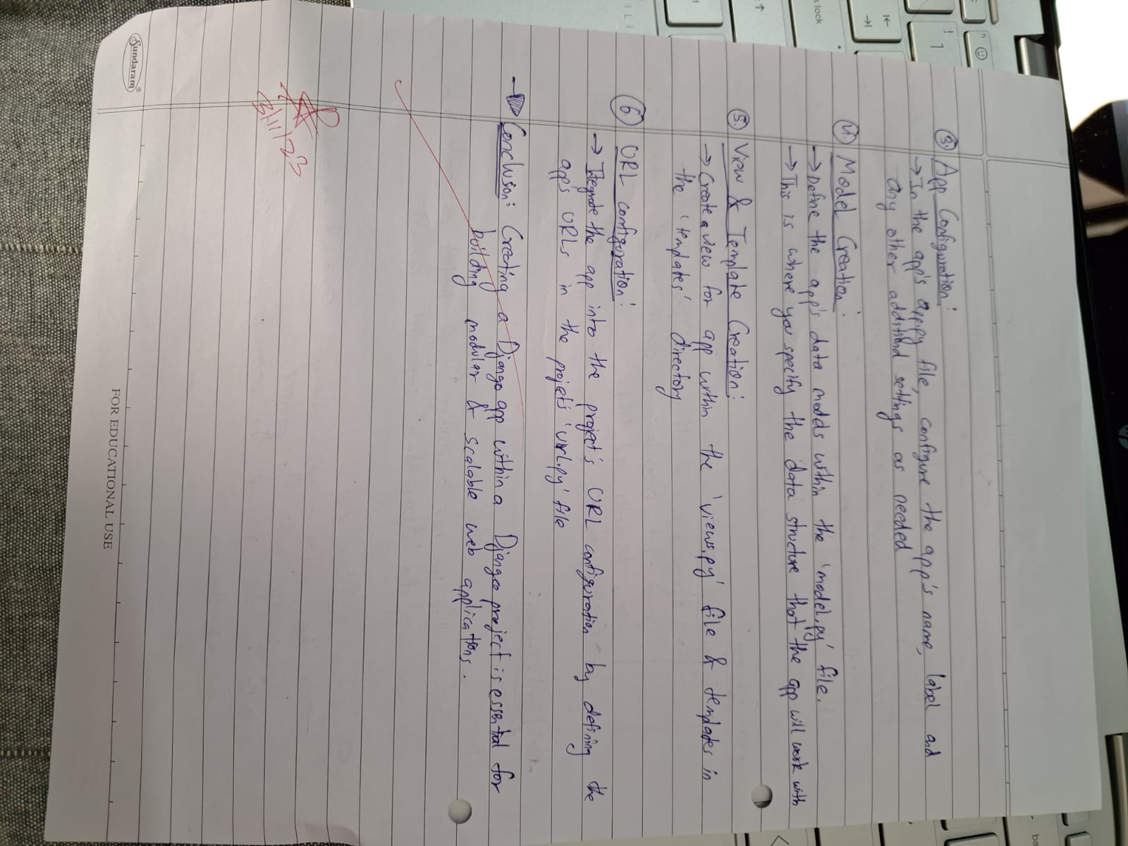

Code:

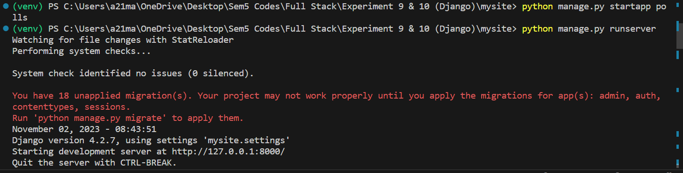

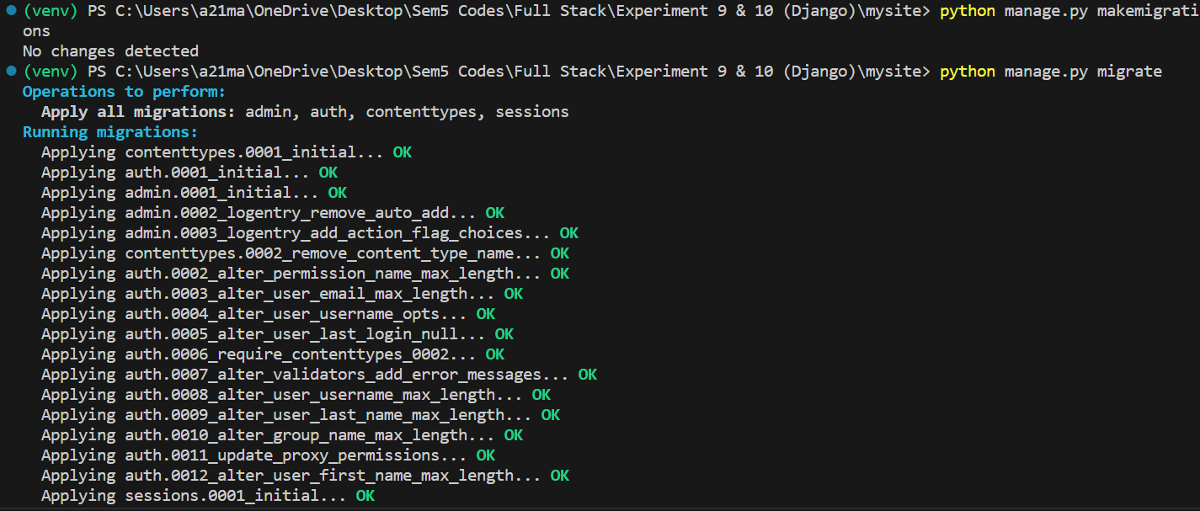

**polls/urls.py:**

from django.urls import path

from . import views

urlpatterns = [

    path('', views.index, name="index"),

]

**mysite/urls.py:**

"""

URL configuration for mysite project.

The `urlpatterns` list routes URLs to views. For more information please see:

    https://docs.djangoproject.com/en/4.2/topics/http/urls/

Examples:

Function views

    1. Add an import:  from my_app import views

    2. Add a URL to urlpatterns:  path('', views.home, name='home')

Class-based views

    1. Add an import:  from other_app.views import Home

    2. Add a URL to urlpatterns:  path('', Home.as_view(), name='home')

Including another URLconf

    1. Import the include() function: from django.urls import include, path

    2. Add a URL to urlpatterns:  path('blog/', include('blog.urls'))

"""

from django.contrib import admin

from django.urls import path, include

urlpatterns = [

    path('admin/', admin.site.urls),

    path('polls/', include('polls.urls')),

]

**polls/views.py:**

from django.shortcuts import render

from django.http import HttpResponse

# Create your views here.

def index(request):

    return HttpResponse("Hello, world. You're at the polls index.")

Output: Learnt how to

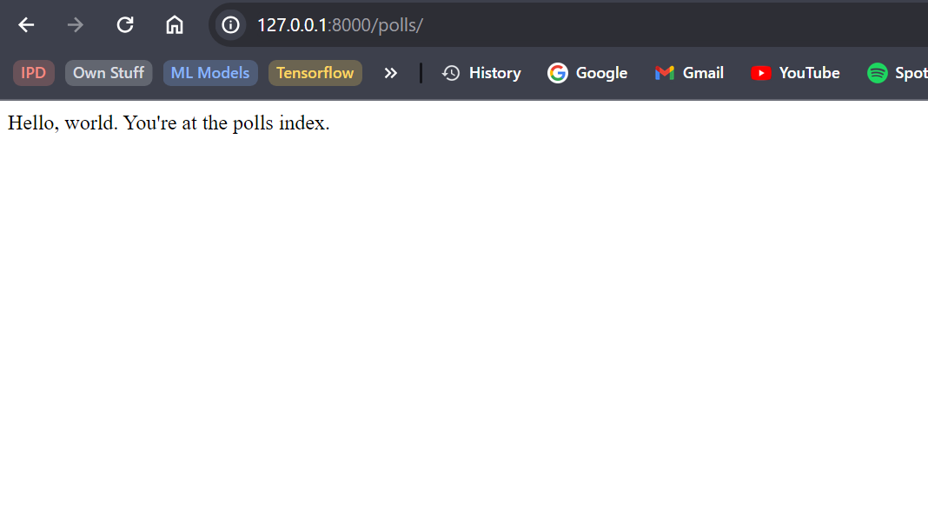

Conclusion: Learnt how to start an app in my Django project and create a basic HttpResponse view.